



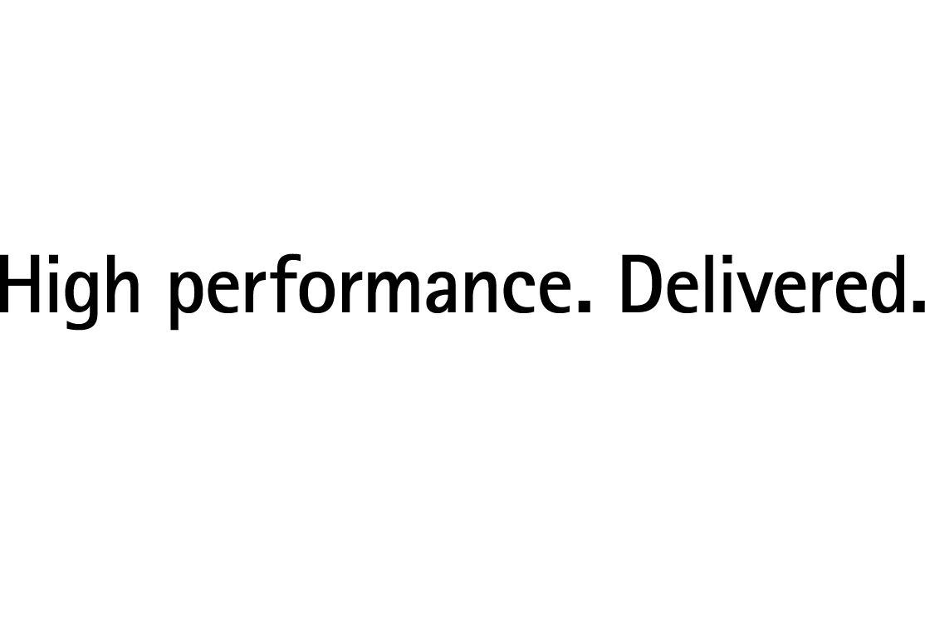

**Innovation Jockeys 2012**

*The Hunt for India’s most Innovative Minds across Campuses*

Students Briefing Pack

Dear Amit, Deepender and Gursimran,

 Congratulations! You are one step closer to winning the Innovation Jockeys contest!

 We are delighted to announce that your innovation has been further shortlisted and we are giving you an opportunity to present your idea to our esteemed jury members on **Tuesday, 24th April 2012** in Bangalore.. Basis the presentation the jury members will decide on the final winners under each category and also the overall winner.

Please refer to this document as your guide for your trip to Bangalore. Your point of contact from the Accenture team is **Sonya Suvarna**. Her contact number is: **09901380111**

Gursimran – Since you are in Bangalore itself, you can contact your friends when they arrive Bangalore or go straight to the house.

**Time slot for Presentation**

2: 25 – 2:40 PM – Presentation to Jury Members

2:40 – 2:45 PM – Q&A session with the jury members

We will be referring to the presentation you have already submitted earlier. Request you to please prepare yourself to adhere to the time allocated.

Congratulations once again and good luck on your presentation!!

Regards

**Innovation Jockeys Team**

**Innovation Jockeys 2012**

**Frequently Asked Questions for Grand Finale Participants**

1. **How should I book travel and stay?**

We will book your return travel and stay in Bangalore. You would need to present to the jury members on April 24th and the grand finale is on the same day. You will be traveling to Bangalore on April 23rd and your return journey is booked for April 25th.

1. **Where will I be staying? Do I need to book accommodation?**

You will be staying at a pre-selected Accenture guest house. Guest house bookings will be managed by the Accenture team. Accommodation details will be communicated shortly.

1. **How will I travel from office to the airport and within Bangalore?**

There will be ground transportation at the airport to bring you to the venue. Please contact

**Wasim: +919945544318.**

1. **Who should I contact, from the Accenture Team, in case of any problem?**

Please reach out to any of the following people:

* **Sonya Suvarna: 09901380111**
* **Vimala MV: 09886687912**
* **Puja Gupta: 09818883851**

1. **Where do I need to go on arrival?**

On arrival, there will be a car waiting for you and will take you directly to the guest house which has been booked for you. Enclosed are the details:

**Maple Leaf**

# 295, 2nd main road,   
J.P.Nagar, 3rd Phase,  
Bangalore - 560 078

Ph: +91 80 41209741 /42 / 43

1. **At the time of check-in who do I contact?**

Please get in touch with **Shivali Prakash** or the guest house manager **–**

**Mr. Nagaraj Mob No : 8970152143**

1. **At what time is my presentation to the jury members? How much time will I get to present.**

Enclosed are the presentation details:

**Time slot for Presentation**

2: 25 – 2:40 PM – Presentation to Jury Members

2:40 – 2:45 PM – Q&A session with the jury members

1. **What time do I need to reach the hotel?**

You will need to reach the **Hotel Leela Palace by 11:00 AM on April 24th**. There will be a cab waiting for you at the guest house to bring you to the Hotel. The cab details will be shared with you on arrival.

1. **Should I release the cab?**

Request you not to release the cab.

1. **What facilities can I avail of in the guest house?**

The document in your guest house room details free/chargeable services. Any chargeable expense incurred will be needs to be borne by you.

1. **Will Accenture bear my phone expenses?**

Accenture will not bear your phone or any other incidental expenses (for example, STD calls, in-flight meals etc.) that you may incur during the course of travel.

1. **What all expenses will be taken care by Accenture?**

Your flights and travel to and fro from the venue, meals during your stay will be organized by Accenture.

1. **Is there a dress code I need to follow for the finale?**

Please dress in business formals

1. **Can I step out on my own during my free time?**

You are not allowed to step out during the day. Incase you need anything please get in touch with Sonya Suvarna. At all times please be in touch with your contact person.

1. **Do I need to share any contact details with Accenture?**

Request you to please share the phone numbers and e-mail ids of your Parents/Guardian and your placement officer. We will be reaching out to them

**Flight Details**

|  |  |  |  |  |  |  |
| --- | --- | --- | --- | --- | --- | --- |
| **Name** |  | **From** | **To** | **Date** | **Arrival** | **Departure** |
| Amit Ranjana | Thapar University | Chandigarh | Bangalore | 23rd April 2012 | Jet Lite, S24235 | Jet Lite, S24238 |
| Deepender Singla | Thapar University | Chandigarh | Bangalore | 23rd April 2012 | Jet Lite, S24235 | Jet Lite, S24238 |
| Gursimran Singh | Thapar University | Chandigarh | Bangalore | 23rd April 2012 | Jet Lite, S24235 | Jet Lite, S24238 |

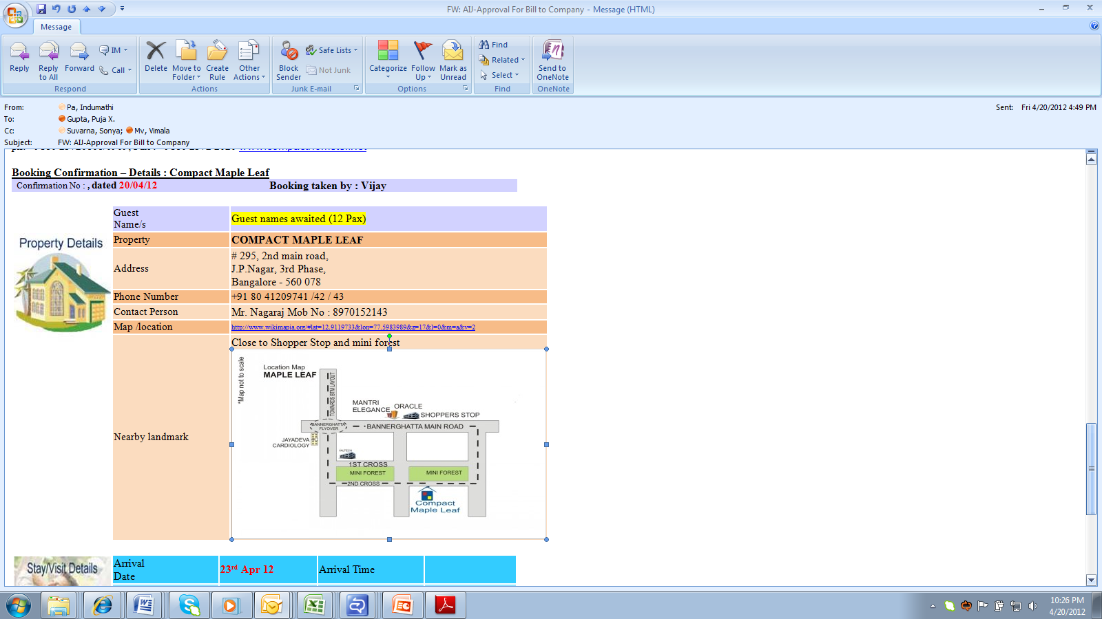

**Please note: Carry print outs Flight/cab and Guest House along with you just in case you need to refer to the details at any given point of time. Request you to please carry your College ID card along with you as well.**

**HS BAWA - 94172-55252**

Copyright © 2012 Accenture

All rights reserved.

Accenture, its Signature, and

High Performance Delivered

are trademarks of Accenture.